

Best Practices

Concierge Maintenance

Administration Feature

Concierge Staff

The first step to using The Concierge Assistant is to register the staff members and establish a level of authority for each viewer. Each associate will have a logon name and establish a password.

The Concierge Staff feature includes the ability to track associates who have language skills and speak another language in addition to English. For a more in depth discussion of this function please refer to the “Language Only” section of this document.

The Concierge Assistant has five (5) levels of viewer authority. The information entered when establishing the staff member will determine the features and the amount of information that the staff member can access.

All of the various “Message Groups” within your property that will be using The Concierge Assistant will need to be established. To do this, type the name of the group in the “Message Group” space and click on the “Add Group” button. You may also delete groups that are not applicable to your property. Simply click on the unwanted group and click on the “Delete” button.

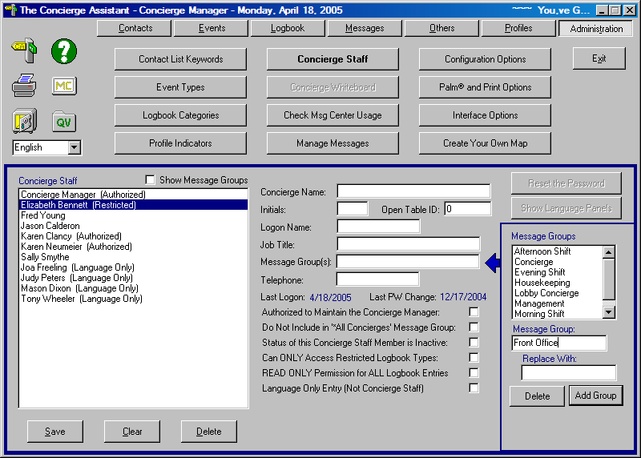

This information is necessary for linking specific employees to their working message group(s) for use in the Messaging Feature. Each employee can be linked to as many groups as applies.

Each associate, the very first time they sign on to The Concierge Assistant, will need to establish their individual password. To do this, the associate will enter their logon name in both the logon name space and the password space. CA will then present a screen to establish the password that the associate will be using. They will enter their password in the first space and then re-enter the password a second time to verify their new password and then click on the OK button. From then on their logon name and the new password will be entered for logging on.
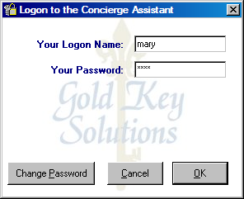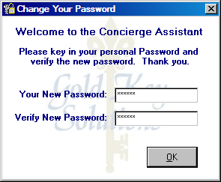

Authorized Users

“Authorized Users” are also referred to as “Administrators” as they have access to all of features of The Concierge Assistant, including the Administration tab. This level of authorization should be given primarily to Supervisors and Managers of the various groups using The Concierge Assistant, as this level is the very highest level of usage available.

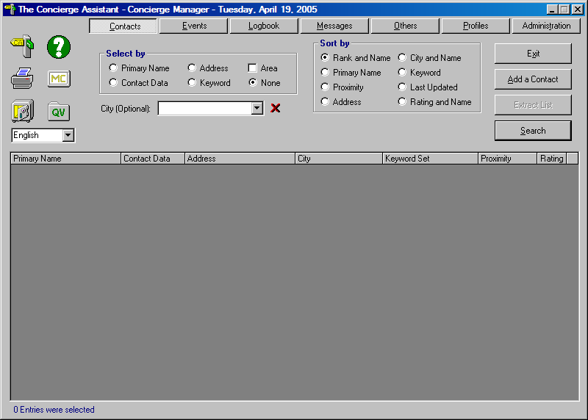

The Administration tab controls the structure of The Concierge Assistant. Under this tab the foundation of The Concierge Assistant is established and changed when policies dictate. (Each button is discussed individually in its own document.) The “Authorized User” has access to every aspect of The Concierge Assistant.

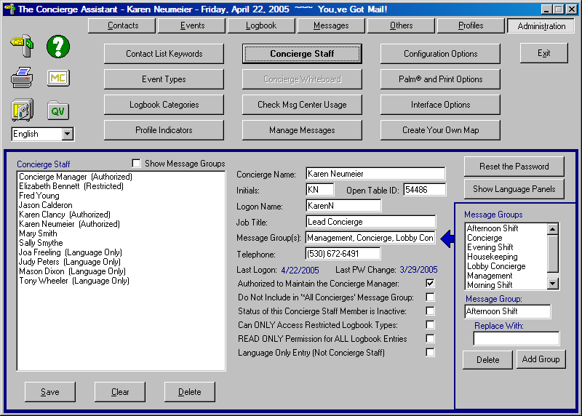

To establish a staff member highlight the “Concierge Staff” button and fill in the spaces as they are in the example above. (This will be the same regardless of the user authority of the staff member.) 1. Concierge Name, be sure this is typed properly as it will be the name that appears on the Confirmation notices of the logbook entries made by this person. 2. The “Initials” will appear on logbook entries with the date and time of each change. No two sets of initials can be the same therefore, if you have a duplication of initials just add the middle initial or a number to make it different from the other. 3. Open Table ID: enter the employees Open Table ID number. 4. The Logon Name is the name that the individual will use for signing on to The Concierge Assistant, it never needs to be changed but can be changed if desired.
5. The Job Title of the employee. 6. The Message Group will be at least one (1) of the Message Groups established on the right of the screen. Highlight the applicable group and double-click on the fat arrow to the immediate left, it will populate the space with the Message Group selected. You can have as many Message Groups as needed. 7. The Telephone space should be filled in with the telephone number, beeper number, cell number or extension of this associate. This information will be available to you when performing maintenance to the Concierge Assistant (refer to document “Check for Logged On Users”).

What makes an “Authorized User” is the first small box directly under the “Telephone” space. Put a checkmark in this box. If this employee has language skills and speaks another language in addition to English, please click on the button labeled “Show Language Panels”. (Refer to the “Language Only” section of this document). The “Authorized User” has been established. Don’t forget: the first time this person signs onto The Concierge Assistant, their password will be the same as their Logon name.

Full User

The “Full User” is the next level of user in The Concierge Assistant. They have the rights to all of the features in The Concierge Assistant with the exception of the Administration tab.

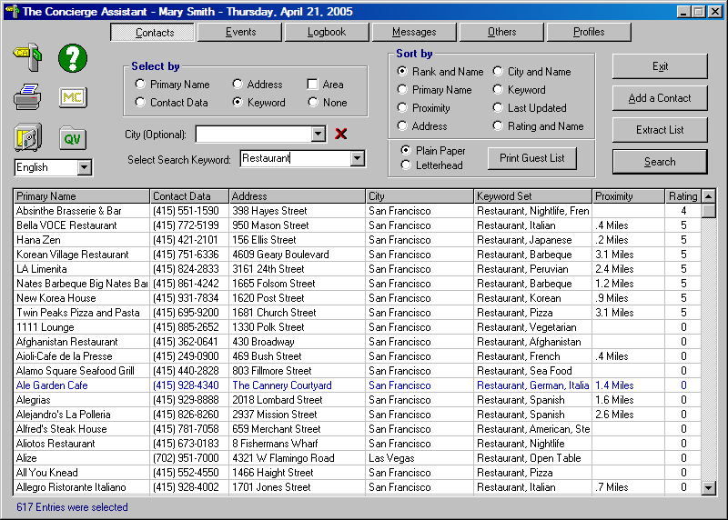

To establish a “Full User” fill in the “Concierge Staff” information as it is below with no additional boxes checked. If this employee has language skills and speaks another language in addition to English, please click on the button labeled “Show Language Panels”. (Refer to the “Language Only” section of this document). Don’t forget: the first time this person signs onto The Concierge Assistant, their password will be the same as their Logon name.

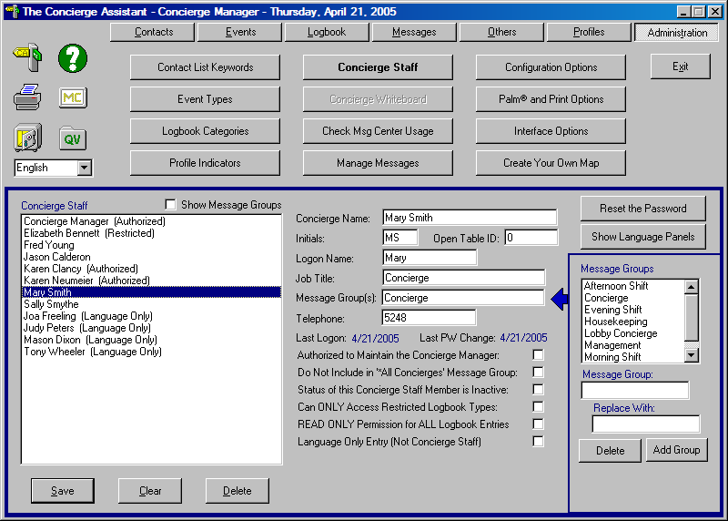

Read Only Logbook Viewer

The next level of user, we’ll call the “Read Only Logbook Viewer”. This viewer has the ability to do almost everything that a “Full Viewer” can with the exception of the Logbook entries. In this area, the viewer is a “Read Only” user.

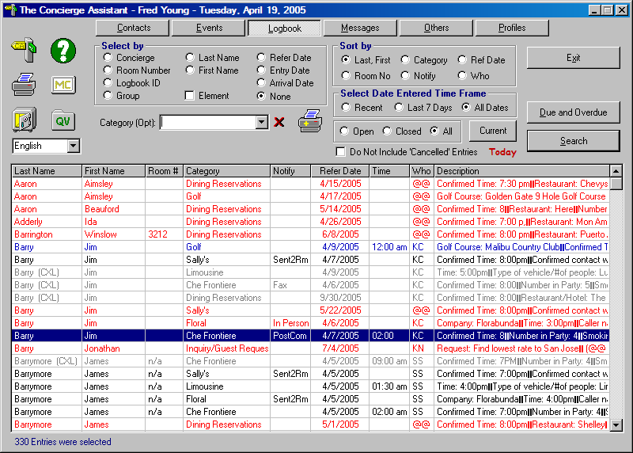

To establish a Read Only Logbook User, fill in the “Concierge Staff” information as it is below.
If this employee has language skills and speaks another language in addition to English, please click on the button labeled “Show Language Panels”. (Refer to the “Language Only” section of this document). Don’t forget: the first time this person signs onto The Concierge Assistant, their password will be the same as their Logon name.

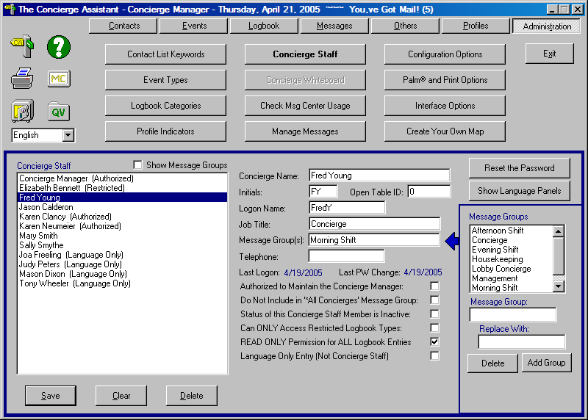

Restricted Viewer

The next level of authorization is a “Restricted” viewer. At this level The Concierge Assistant screen looks like the one below and the access is very similar to the “Guest” viewer limiting the user to “Read Only” right in all areas of The Concierge Assistant, with the exception of the Logbook and The Others tab.

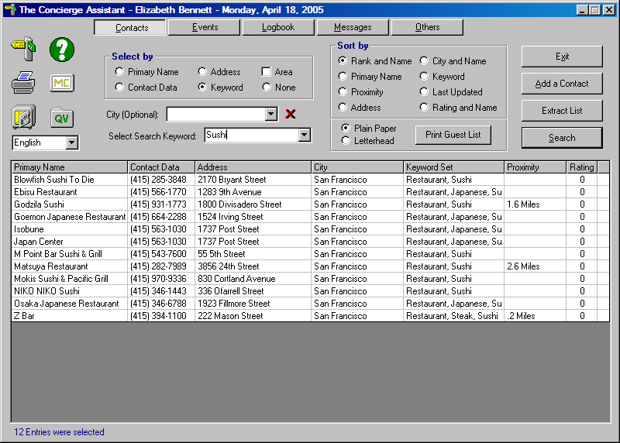

As a “Restricted” viewer, the employee is not allowed to add or change information in any feature with the exception of specific Logbook types that are established as being accessible by “Restricted” viewers (See Administration – Logbook Categories), such as Lost and Found Items for Housekeeping or Package Processing for Shipping and Receiving. These viewers have the ability to view only the logbook entries associated with the Logbook types they are restricted to.

Under the “Others” tab there is restricted viewing access to “Groups”, “Rental and Inventory Items” and the “Logbook Report Writer” reflecting only those Logbook types selected for “Restricted” viewers.

Restricted viewers may be given access to both the Message feature and the Rental and Inventory feature if those options are selected (see Administration – Configuration Options).

To establish a “Restricted” viewer, fill in the “Concierge Staff” form out and check the appropriate boxes as it is below if the viewer will not be allowed access to the Message feature. If you want this person to remain “Restricted” but you would like to allow them “Read Only” permission for the other Logbook categories, put a check mark in the box labeled “READ ONLY Permission for ALL Logbook Entries”. If this employee has language skills and speaks another language in addition to English, please click on the button labeled “Show Language Panels”. (Refer to the “Language Only” section of this document). Don’t forget: the first time this person signs onto The Concierge Assistant, their password will be the same as their Logon name.

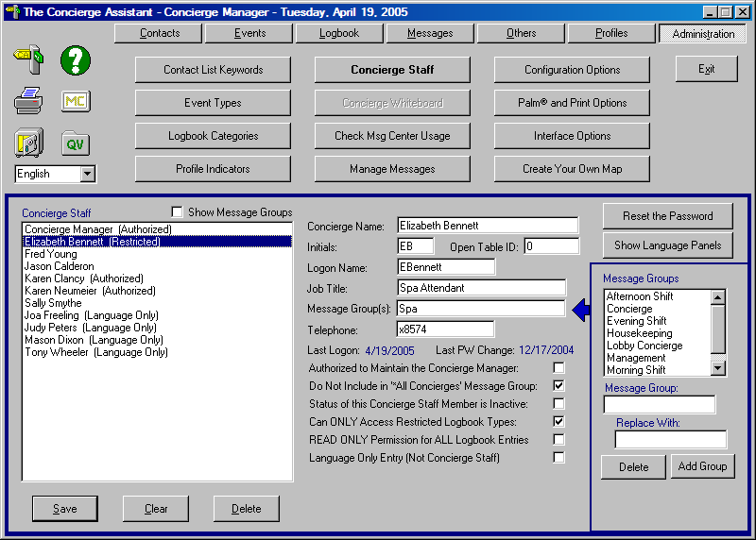

Guest Viewer

The first level of authority is referred to as a “Guest” or “Read Only” viewer. For this level of authority it is not necessary to establish a concierge staff member. The logon name is “guest” and no password is necessary for all viewers at this level. It allows the viewer to look at information in the Contacts, Event, and Logbook features but will not allow the viewer to make any changes or additions to the existing database. If access is attempted, the system will notify the viewer with a message like the one below. The Message button is visible but not functional at this level.

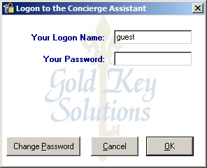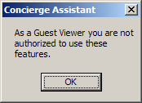

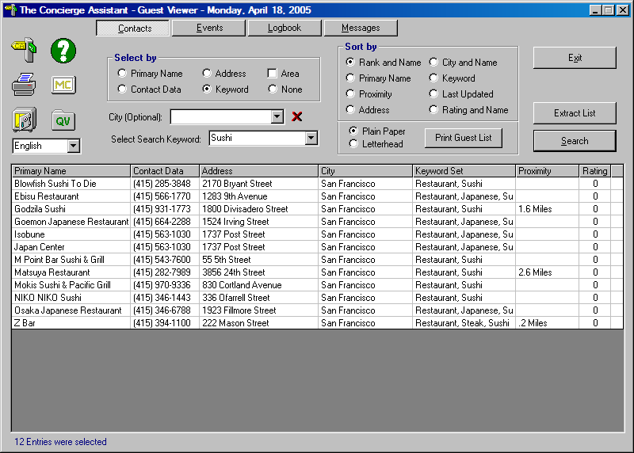

Other areas that allow access with limited viewing at this level include the Internet browser (the Question Mark [?]), The Message Center (MC), the Quick Viewer (QV) (limited to Quick View lists, calculator and Calendar) and the Function keys (F2 through F6).

Language Only

The Concierge Assistant is capable of keeping track of the language skills of various associates throughout the property, whether they use The Concierge Assistant or not. Each employee can be designated with their specific language skill(s) and can be found easily by clicking on the function key F5. Sometimes it can come in handy when you need someone to assist you with a guest who may not speak English fluently and finds communicating difficult.

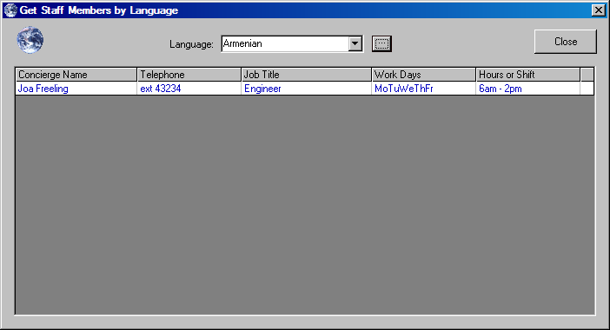
A “Language Only” staff member does not use the Concierge Assistant but is included in the staff members as an associate with language skills in another language other than English, such as Spanish, French and German. To establish this type of staff member fill out the staff information as follows and then click on the “Show Language Panel” button. You will follow this same procedure for each staff member having language skills no matter their authority or usage level.

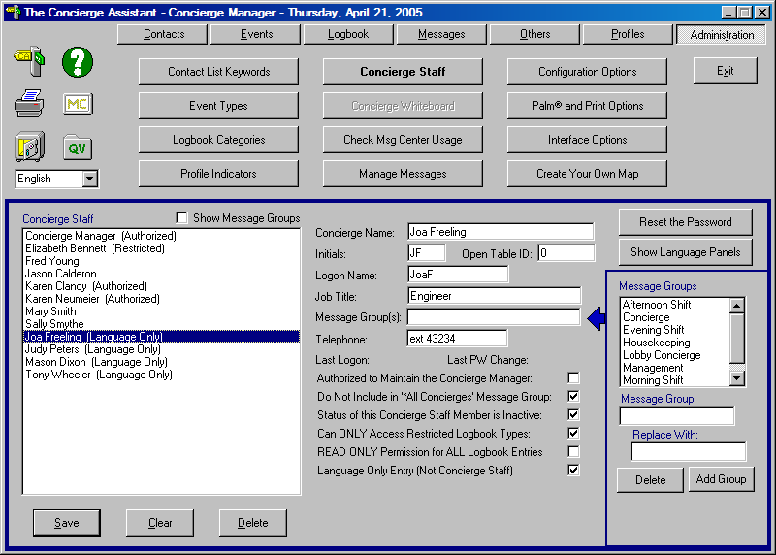

Double Click on the language(s) that apply to this associate and fill in the work schedule if you know it.
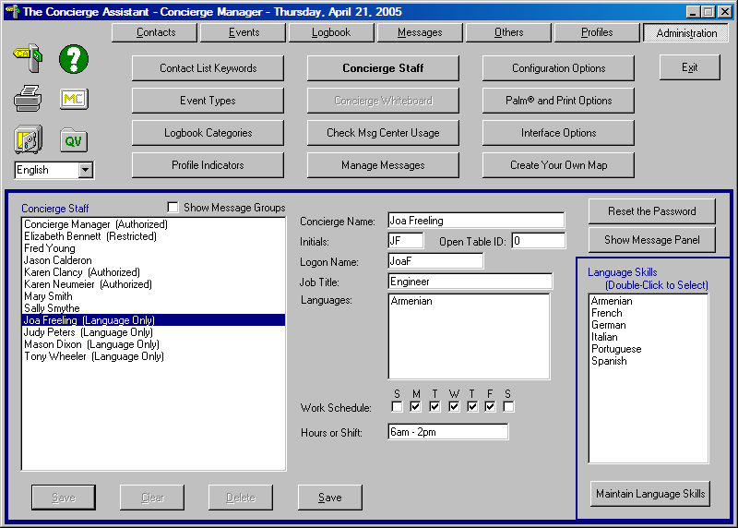

Want to add additional languages? Click on the button “Maintain Language Skills”.

